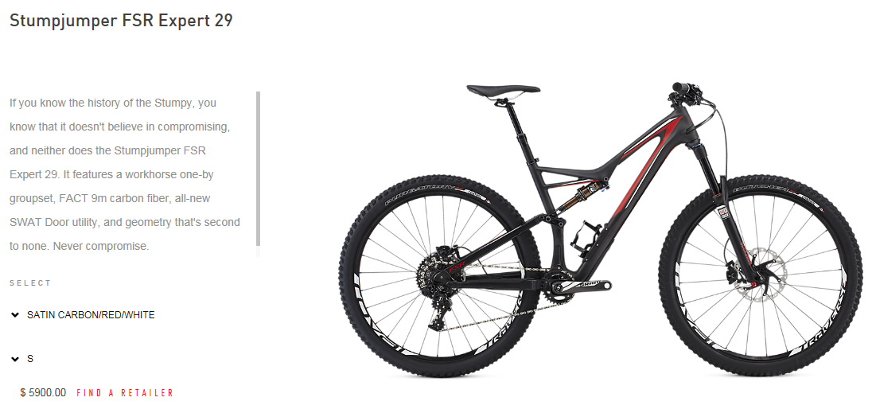
Stolen in Missoula 6/10/16 Serial number WSBC604252967K
This Bike is teal in color and brand new. Any information please call Dave @406-698-5360

